Welcome!
Date
Name
Spouse
Address
City
State Zip _________
Email

Please Contact By
❑ Card  Phone  Visit

Telephone Best Time to Call
Home ______________
Work ______________

Guest: First Time Second Time
Are you a church member: yes no
Church
City, State

Circle Appropriate Age/Grade Group(s)
Preschool: Ages: B-1 2-3 4-5
Children: Grades: K 1 2 3 4 5 6
Youth: Grades: 7 8 9 10 11 12
Adults: Ages:18-29 30s 40s 50s 60s+

How did you learn about our church?
Newspaper Friend Yellow Pages Mail
Other

I am a guest of:

New in the Community? Yes No
Names & ages of children at home

Weekly Service & Activity Schedule

August 30, 2015

9:45 a.m. Sunday School
11:00 a.m. Worship Service
6:00 p.m. Evening Worship Service

Week of August 30, 2015

Wednesday 7:00 pm Adult Bible Study

Upcoming Events
September
5………..…….....……80th Birthday Party for Cleyon Davis
10………..……………………………………Adult Fellowship
12………..…..…..Living Proof Live Simulcast FBC Rogers
13………..……………………..……………Business Meeting
13-19….….….Week of Prayer – Mary Hill Davis Missions
23….See You at the Pole (Global Week of Student Prayer)

Ladies, join us for Ashley Smothermon’s baby shower today after the worship service in the Fellowship Hall



Sat. Sept. 12 @ FBC Rogers – Sign- up sheets on bulletin boards in Sanctuary and Sunday School hall or contact Patti Radford 512-968-7821 by today.

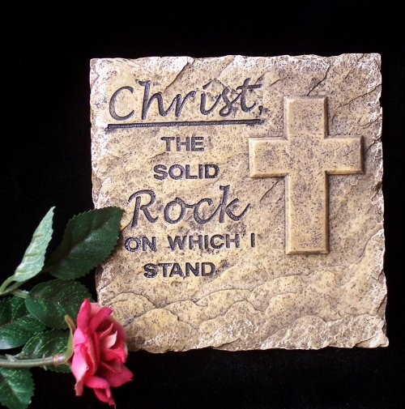

Knobbs Springs Baptist Church

August 30, 2015


Church Information:

KnobbsSpringsBC.com KnobbsSpringsBaptist@gmail.com
1662 CR 305, McDade, Texas 78650 512-273-2743

David Atwood, Pastor Cell 512-470-5098
Home 512-856-2819
Patti Radford, Office Manager Cell 512-968-7821

